BA Intro
Business Analyst -> helps organisation by defining needs & drafting the solution needed to be required to improve the org.
Uses structured framework to make decisions. Exploring different options, assessing risks and benefits, and ensuring that solutions align with business goals and success measures.
BA Competencies:
- Facilitation: group leading in discussion in gathering requirements
- Problem solving: find actual root cause of an issue so solution isn’t a bandaid
- Negotiation: with stakeholders, reach mutually agreeable decisions

BA Foundations
Categories of business needs:
- Problems
- New opportunities
- Compliance req
Start with identifying the need, imagine a future state, identify the gaps between current and future. The ‘output’ is situation statement and solution statement.
Tools for identifying need : Ishikawa diagram, five whys

Stakeholder Analysis
Stakeholders -> everyone who is impacted/can impact a project
Framework for identifying stakeholders: power/interest matrix

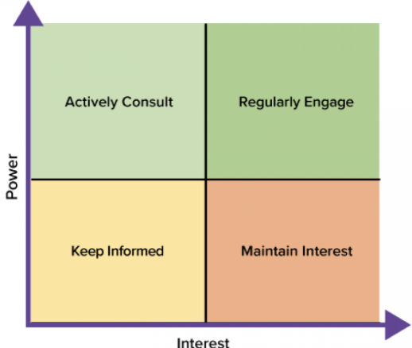
Stakeholder involvement is vital to project (see pmbok Stakeholder Management)
Management, communication, monitoring stakeholders is part of BA work.

Business Case
Justifies the resources needed for a project, derived from needs analysis and stakeholder input.
Includes: analysis of benefits, costs (including ongoing support), and feasibility
Prevents: projects risk scope creep, cost overruns, delays, or delivering solutions that don't meet stakeholder needs

Project Planning
Starts with vision -> clear, concise statement of the desired outcome, answering five whys
Create a roadmap from it: timeline of major milestones, dependencies, and resource needs

Tools for BA

traceability matrices
Example:
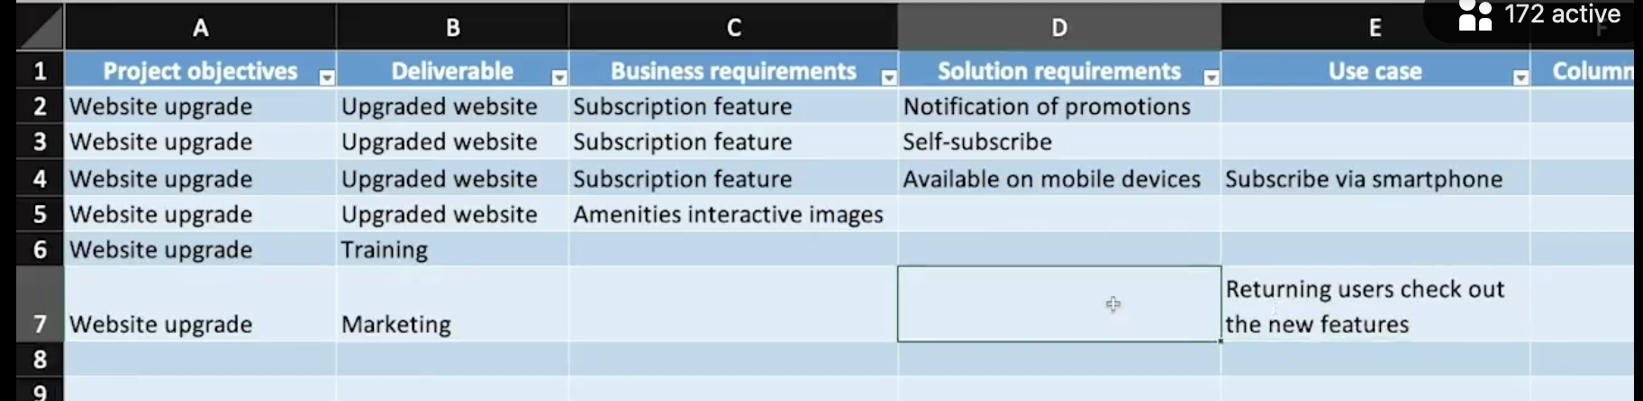

Start with objective (why), figure out deliverable (what), the solution requirement (how)
Business requirement is ‘high level story’
Solution requirement is more granular, something like functional req
Can be expanded to for testing/test cases
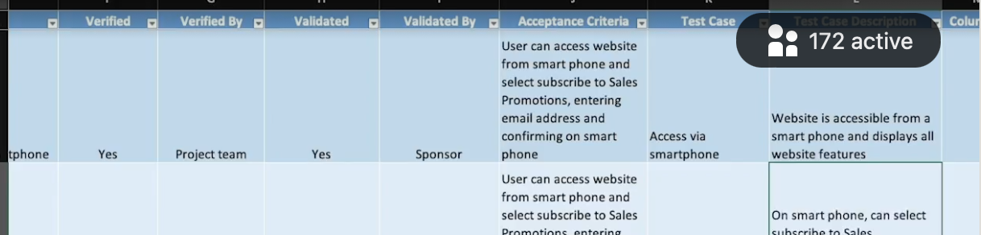

Process Modeling
High level visual of how a process is step by step
Start with the ‘single line’ step by step like so
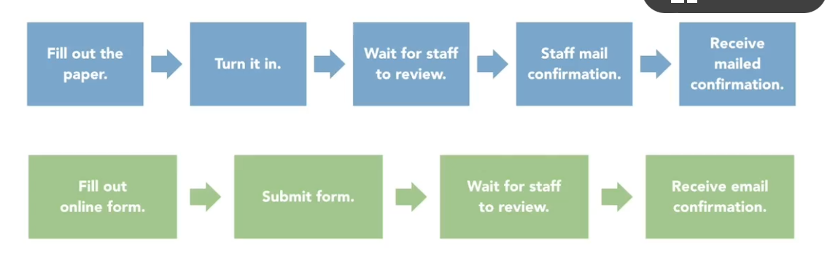

Then use swimlane to define actors (who does what part)
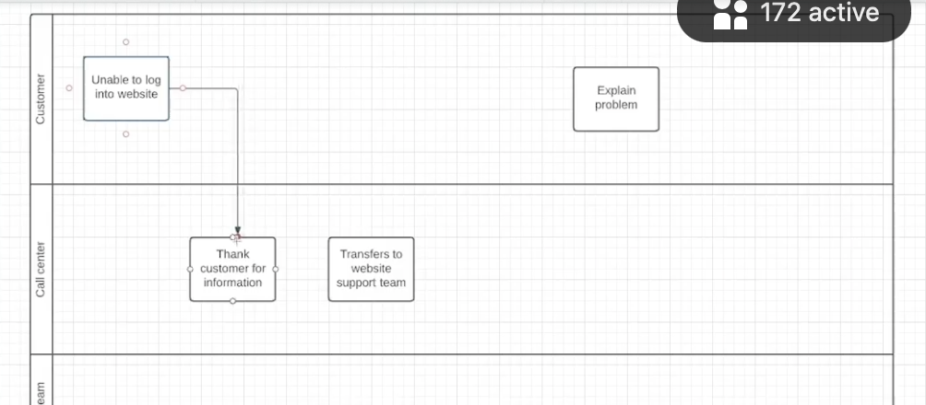

Context Diagram
Context diagrams focus on what’s in scope and the connections, not on process steps or organizational hierarchy
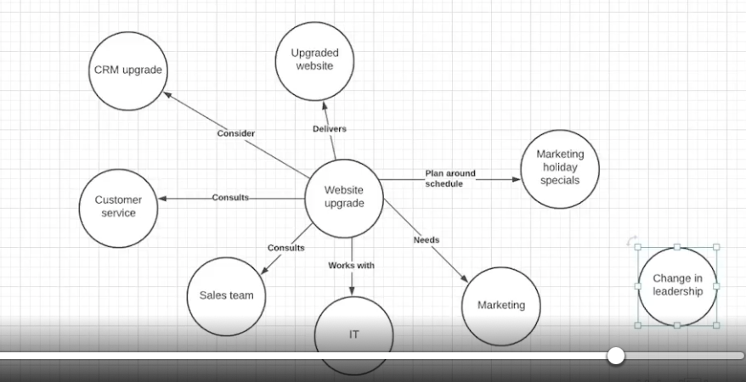
Another variation is Data Flow Diagram, which is context diagram with a bit technical stuff about data
